UNICEF Global Deprivation Index It is an index that measures child poverty using a multidimensional approach, taking into account various indicators related to health, education, and living standards. The index was first developed in 2012 and has since been updated to reflect new data and evolving measurement approaches.

The UNICEF Global Deprivation Index is designed to complement traditional income-based measures of poverty by providing a more holistic picture of child well-being. It is based on a framework that identifies different types of deprivation that children may experience, such as lack of access to clean water, adequate nutrition, or schooling.

The Index is calculated for a large number of countries and provides policymakers with valuable information on the specific areas where interventions are needed to reduce child poverty and improve child well-being. The UNICEF Global Deprivation Index is one of several tools used by the organization to monitor progress towards the Sustainable Development Goals, particularly Goal 1: No Poverty and Goal 10: Reduced Inequalities.

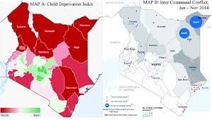

UNICEF Global Deprivation In

Scattered plot

A scatter plot, also known as a scatter diagram, is a graphical representation of data that displays the relationship between two variables. Each point on the plot represents a single observation or measurement, and the position of the point on the plot is determined by the values of the two variables being plotted.

The horizontal axis of the scatter plot represents one variable, while the vertical axis represents the other variable. The data points are then plotted on the graph, with each point’s position representing the values of the two variables for that observation.

Scatter plots are useful for visualizing patterns or relationships in data, particularly when exploring possible correlations between variables. They can also be used to identify outliers or unusual observations in the data.

In some cases, a line of best fit or trend line can be added to a scatter plot to help visualize the relationship between the variables more clearly. This line is typically a straight or curved line that passes through the data points and provides a visual representation of the overall pattern of the data.

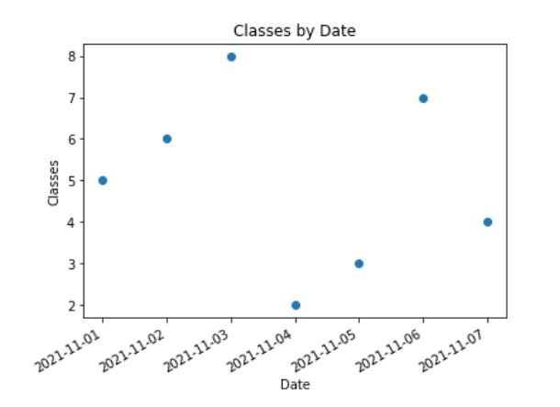

Bar plot

A bar plot, also known as a bar chart, is a graphical representation of data that uses rectangular bars to represent the values of different categories or groups. The length of each bar corresponds to the magnitude or frequency of the variable being measured.

The horizontal axis of the bar plot represents the categories or groups being measured, while the vertical axis represents the frequency or magnitude of the variable being measured. The bars can be oriented either horizontally or vertically, depending on the type of data being displayed and the preferences of the viewer.

Bar plots are useful for comparing the relative sizes or frequencies of different categories or groups. They are particularly effective when the categories being measured are discrete and non-continuous, such as the number of people in different age groups or the sales figures for different products.

In addition to standard bar plots, there are also several variations, such as stacked bar plots and grouped bar plots. Stacked bar plots display the total magnitude of each category, broken down into sub-categories, while grouped bar plots display the values of multiple variables side-by-side for each category.

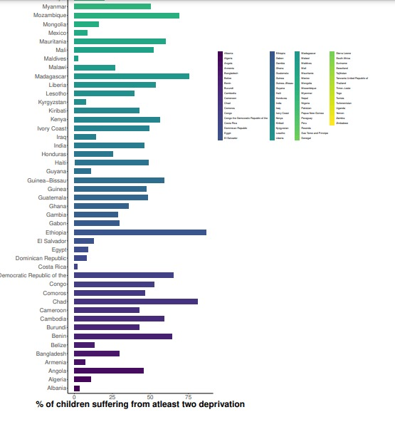

Timeseries

Time series data is a type of data where measurements or observations are recorded at specific intervals over time. The data is usually collected in a chronological order and can be used to analyze patterns, trends, and relationships over time. Time series data is commonly used in various fields, including finance, economics, meteorology, and engineering, among others.

Some examples of time series data include stock prices over time, weather patterns over a season or year, sales figures over time, and medical data recorded over a period of time. Time series data can be analyzed using statistical methods, including trend analysis, regression analysis, and spectral analysis, among others.

